How Lucky is a Bowl of Lucky Charms?

STAT 3743 Final Project

Gavin Duwe

Brenna Brocker

Haziq Rabbani

Kate Coppola

Professor Jay Kerns

Youngstown State University

# Executive Summary

In a box of Lucky Charms, there are eight unique charms. The names of these charms are Hearts, Blue Moons, Unicorns, Rainbows, Tasty Red Balloons, Clovers, Horseshoes, and Stars. All of these are accompanied by oat pieces. In the study, the total amount of charms is the “luck” in each serving size. Before the experiment, there was a noticeable trend of a decrease in “luck” in each serving as one progressed through a box. Which led to the determination of how “lucky” a box of Lucky Charms is. For the experiment, six “family-sized” boxes were used. The procedure was to take one box at a time and pour out one serving at a time, measure the weight of the serving, then pour the serving out onto a flat surface to count the number of charms that serving had. Other variables that were considered were the weight of the container that the charms were poured into and the total weight, which is the container adding the weight of the charms. The total number of charms was counted in each serving. Each individual charm group was calculated as well. All the data collected was recorded on a spreadsheet. The spreadsheet also included the box number and the observation number. After completing all data collection, the next step was to look at the visual data using graphs, plots, tables, etc. R.studio was used to look at these different displays. The type of analysis used is a regression model. After looking at multiple visual displays of the discrete data, it concluded that there was a linear regression between the total number of charms and the bowl in each box. This means that with each bowl eaten in a box, there is a decrease in charms in the bowl. Thus, the evidence found concludes that the “luck” decreases throughout a box of Lucky Charms.

# Introduction

While enjoying a box of Lucky Charms throughout the week, our professor Dr. Kerns noticed a trend in the marshmallows in his bowls of cereal. It seemed to him that by the end of the box, the number of charms per bowl was significantly reduced. Thus, Dr. Kerns asked the question: “How lucky is a box of Lucky Charms;” we set out to answer that question and calculate statistics for the frequency of marshmallow charms per bowl as one goes through a box of Lucky Charms. In this experimental study, the null hypothesis ($H_{0}$) is that there is no observable difference in the frequency of marshmallow charms, and the alternative hypothesis ($H_{a}$) is that there is a decrease in the frequency of marshmallow charms. To analyze these hypotheses, we decided to use a regression analysis.

# Data Collection

To collect the data, the types of charms in the boxes of Lucky Charms, what boxes and tools were available, and the data storage method were taken into consideration. The boxes of Lucky Charms had to be readily available at the local Walmart and they had to include all eight Charms being the rainbows, hearts, horseshoes, blue moons, clovers, unicorns, stars, and tasty red balloons. The boxes that fit these needs were the regular 10.5 oz (about 297.67 g) box, the “Family Size” box at 18.6 oz, and “Mega Size” box at 29.1 oz (about 824.97 g). Ideally, the 10.5 oz box would be selected to find the underlying cause of the trend quicker, but they were in particularly low supply so the family size box at 18.6 oz or 527g that had a serving size of 1 cup (36g) was selected instead. To collect the data, we used a Tupperware container that weighed 28.375g to pour the cereal into and weigh on an electronic scale that is accurate to 0.005th of a gram. The first step in collecting the data was to pour around a cup of cereal into the container and weigh it one at a time to simulate pouring out bowls of cereal one at a time. After recording the weight of the cereal in an Excel document, the next step was to pour the cereal onto a table and count each of the individual charms that were in the bowl and record the numbers into the Excel document. When running into broken charm pieces, each individual charm piece was counted as its own charm. We stored our data in a Microsoft excel document to create a data frame with the headers: box, bowl, observation, totweight, weight, hearts, stars, horseshoes, clovers, moons, unicorns, balloons, and totcharms. There were a few limitations when collecting the data. One limitation had to do with the timeframe in which the data was collected since the project was done over a seven-week summer course and the project was completed within two weeks. Since it is difficult to measure the volumes of oat and marshmallow cereal pieces, thus limiting the ability to get an accurate measurement for their densities. All the boxes of Lucky Charms were purchased from the same Walmart on the same day causing a potential limitation for the boxes we used to vary from the true average box of Lucky Charms. Lastly, there was the limitation of human error specifically in our data collection for example; before it was fixed, box 5 bowl 11 was marked as box 5 bowl 1.

# Information Summary

Using a scatterplot matrix for bowls, total charms, and container weight, some preliminary relationships between the variables can be explored (Figure 1). Firstly, there is a steady decline in the frequency of marshmallows in sequential bowls. Thus, there appears to be a negative linear association between bowl and total charms. This is reinforced by a correlation coefficient (R) value of –0.738; this suggests a strong negative association.

Using a standard stem and leaf display, the total marshmallow charms have a very well-behaved normal distribution throughout the bowl numbers (Figure 2). Therefore, the mean and standard deviation would be insightful statistics on the center and spread of the distribution; the total charms have a mean of 38.38 charms per bowl, as well as a standard deviation of 12.22 charms. Lastly, there were no outliers for the total marshmallow charm distribution.

Initially, the stem and leaf display for container weights visually appears to have a slight tail. A skewness test displays a g bound of .590, and the container weight distribution has a g value of -.534; thus, the distribution is not significantly skewed. Further, the container weights follow a relatively normal distribution using an altered histogram display (Figure 3). Similarly, the mean and standard deviation would thus be insightful statistics on the distribution of the container weights. The container weights have a mean of 47.17 g, with a standard deviation of 6.50 g. There are potential low outliers at 28.21 and 29.155 and a potential high outlier at 67.395.

(Figure 1)

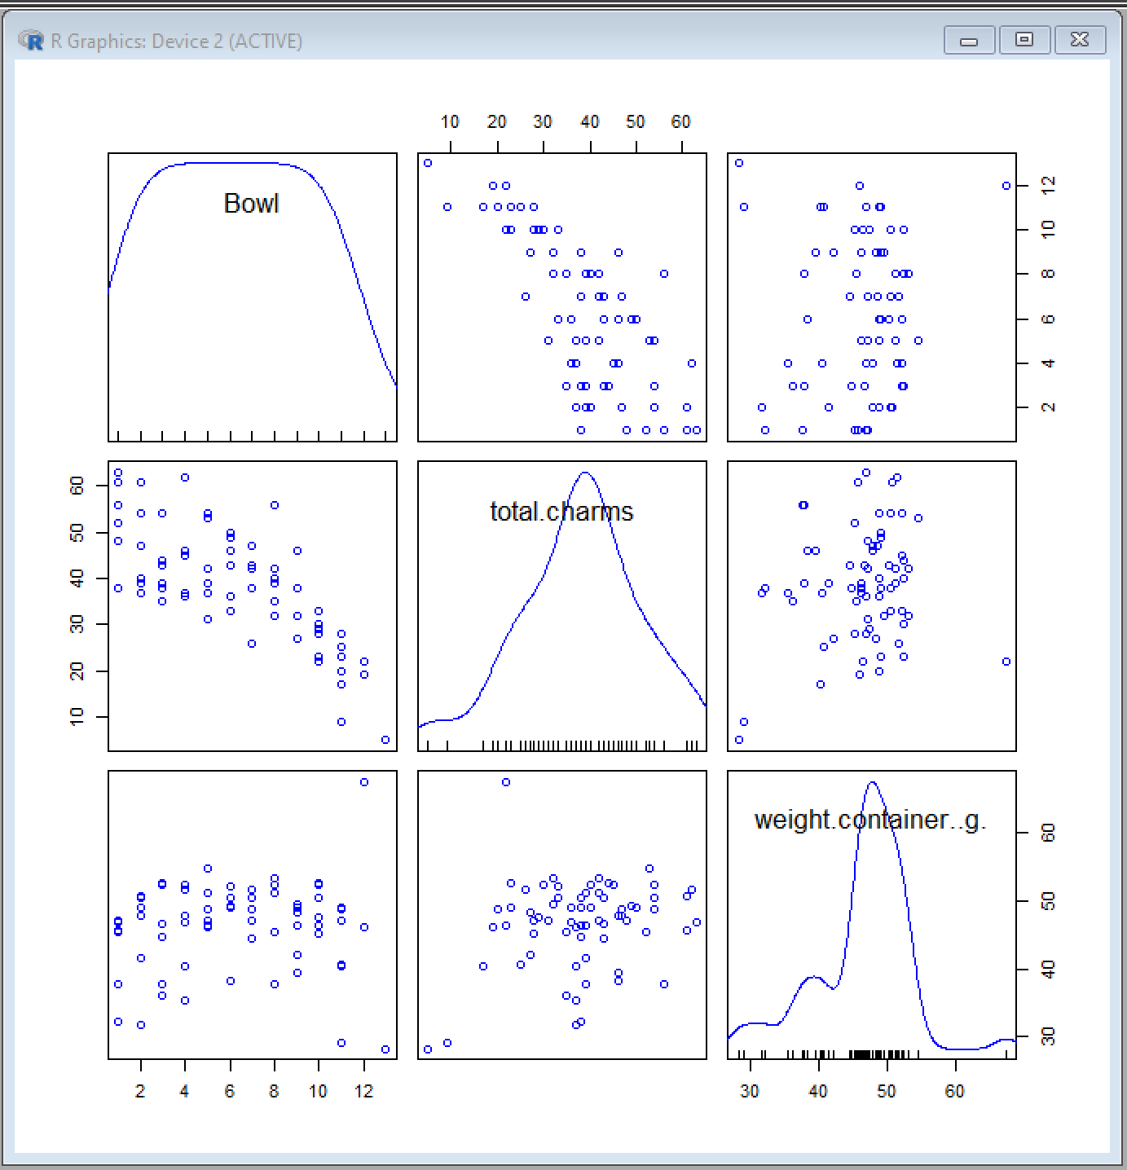

(Figure 2)

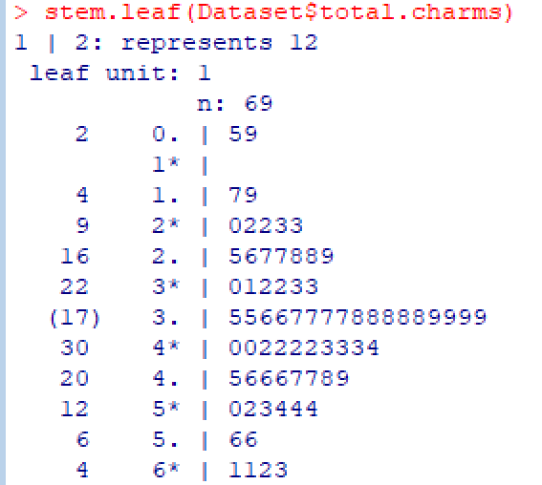

(Figure 3)

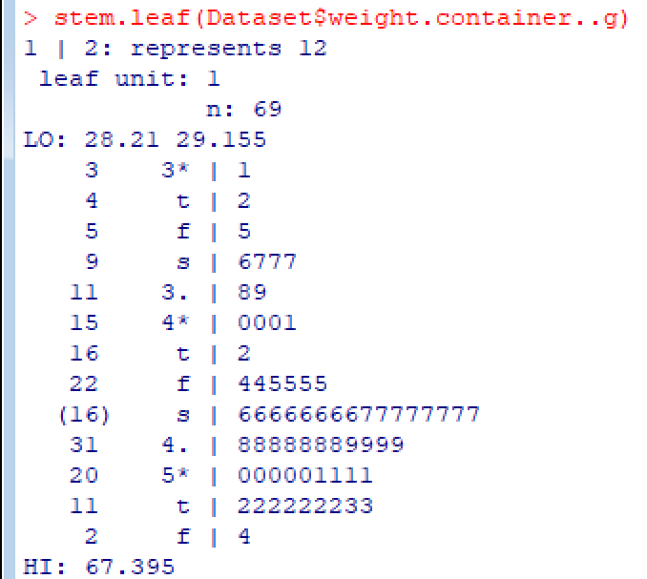

(Figure 4)

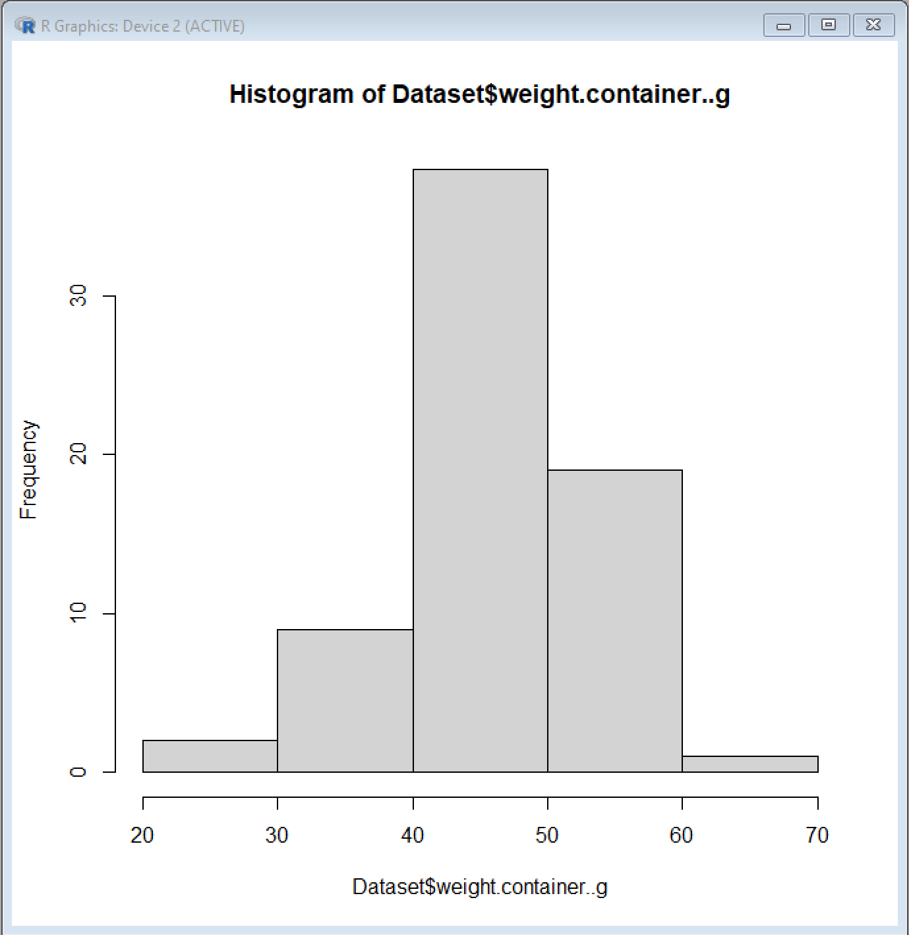

# Analysis

_____________________________________________________________________________________

**Hypotheses**

$$H_{0}:β_{0}=0$$ $$H_{a}:β_{0}≠0$$

$$H_{0}:β_{1}=0$$ $$H_{a}:β_{1}≠0$$

$$H_{0}:β_{2}=0$$ $$H_{a}:β_{2}≠0$$

___________________________________________________________________________

**Statistical Analysis**

The statistical test used to analyze the frequency of marshmallows as the bowl number increased was a linear regression.

The line which displays the regression is fit by:

Total charms = 33.3168 + -2.7552(Bowl number) + 0.4819(weight of container)

_____________________________________________________________________________

**P-values**

Intercept ($$β_{0}$$): 7.78E-6

Bowl ($$β_{1}$$): 1.35E-14

Weight of container ($$β_{2}$$) : 0.00148

Considering an alpha level (α) of 0.05, the observed p-values are highly significant, therefore all the null hypotheses are rejected, and the weight of the container and bowl number affect the frequency of charms. On average, as the bowl number increases by 1, the total charms decrease by 2.7552 charms. Similarly, as the weight of the container increases by 1 gram, the total charms increase by 0.4819. In addition, an analysis of confidence intervals reveals that with 95% confidence, the true $$β_{0}$$ (intercept) is covered by the interval [19.60, 47.03], the true $$β_{1}$$ is covered by the interval [-3.31, -2.2], and the true $$β_{2}$$ is covered by the interval [0.19,0.772]. Lastly, the adjusted R squared value is 0.5976 showing that almost 60% of the data is represented by the above regression.

(Figure 5)

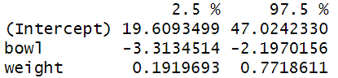

(Figure 6)

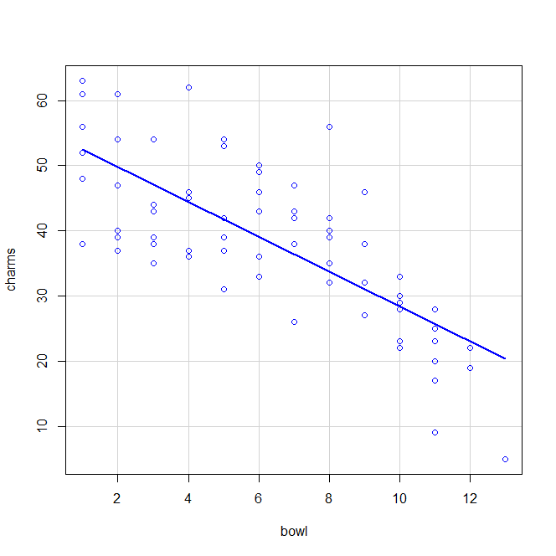

_________

# Conclusions

In conclusion, the data collected in this experiment has indicated a negative linear association between the total charms in a lucky charms box with sequential bowls; in other words, the frequency of marshmallow charms in a bowl decrease as one approaches the end of the box. The adjusted linear regression R2 value of .5976 means that nearly 60% of the data is explained by the regression model using total charms as the observed variable, with bowl number and container weights as explanatory variables. Moreover, the explanatory variables of bowl number and container weight were both observed to be highly significant at an α level of 0.05.

The results indicate that per sequential bowl, the number of marshmallow charms decreases by 2.7552 on average; this trend could be explained by the varying densities between the oat and marshmallow cereal pieces. Further research could be done to test this relationship that could include testing different size boxes for similar trends, shaking boxes before testing to test relative distribution patterns, along with measuring the volumes of the oat and marshmallow cereal pieces to calculate their densities.

The major limitations of this study were that only one type of Lucky Charms box was used (Family size), which may be a confounding factor on the relationship between the bowl number and total charms. Furthermore, the measurements were not exact and could be partly influenced by human error, however, a large sample size likely mitigates this effect. Lastly, we were not able to ensure that all Lucky Charms boxes were sourced from the same factory batch, since this information is not available at the store.